Creating Jekin Job to Build Spring boot project

mvn clean clean or remove old build file

mvn compile compile the maven project

mvn test junit testing

mvn package to jar or war file

mvn install install war or jar file in local repository

**In Jenkin installing custom plugins**

Click on Manage Jenkin

Tools

Adding maven plugin in Jenkin

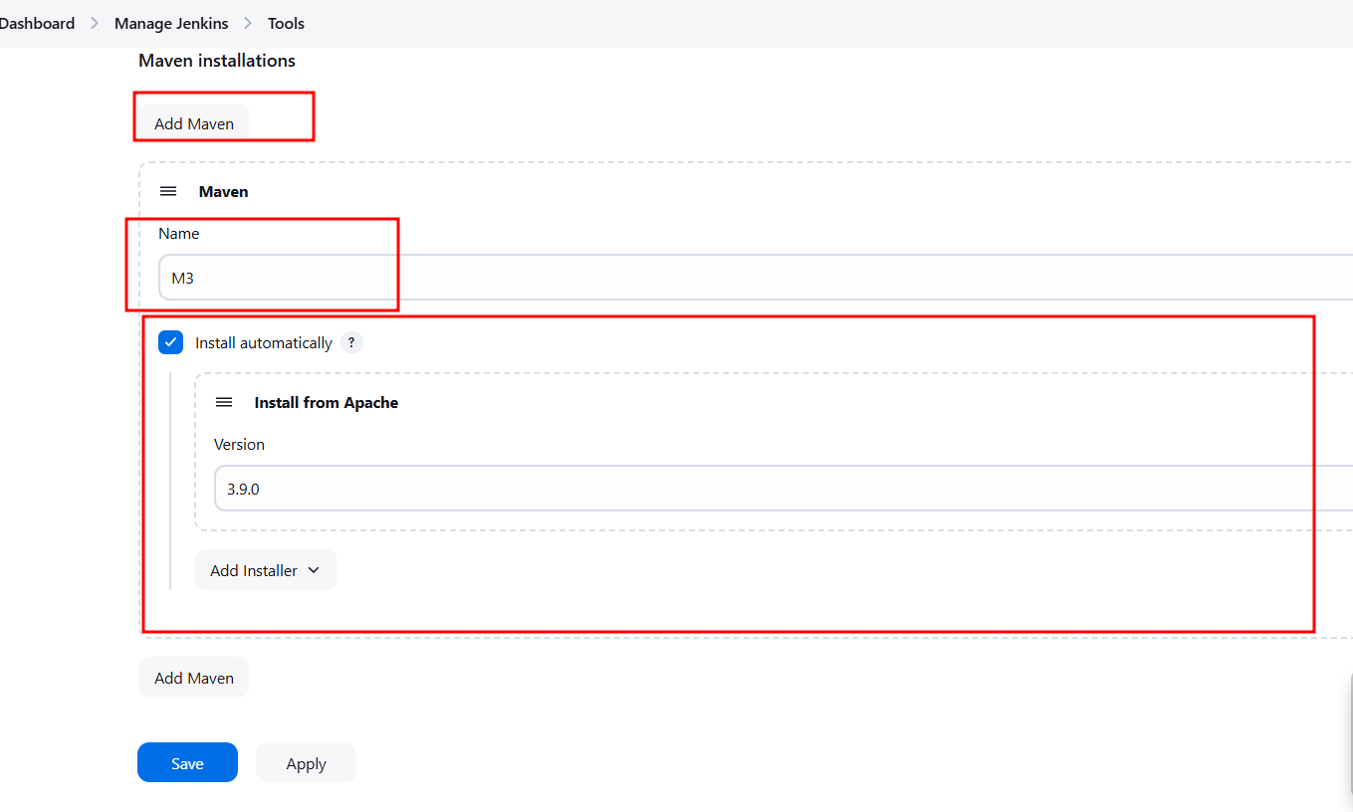

**Jenkin Pipe Line Job**

Jenkin pipe line is used to execute series of command. Those command are interconnected with each other to do specific task. To write these all command we can use Jenkinsfile. Inside this file we write set of instruction.

Creating Jenkin pipe line job to execute custom script file

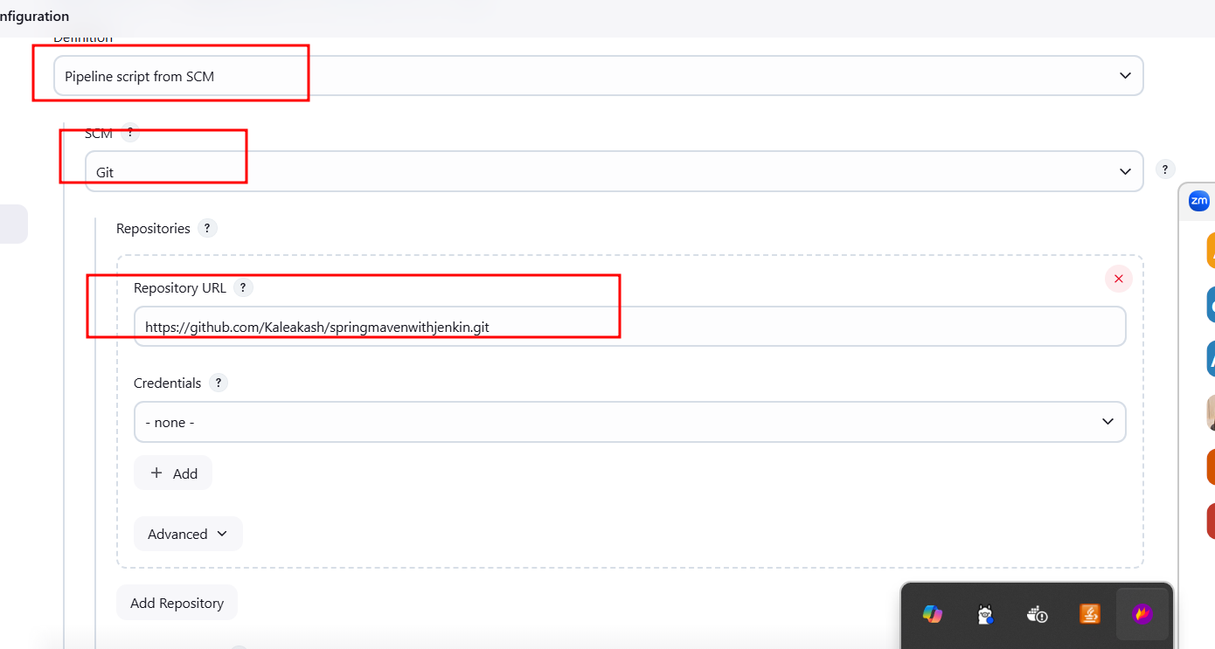

Installing required plugin

Example

Node js

Python

Etc

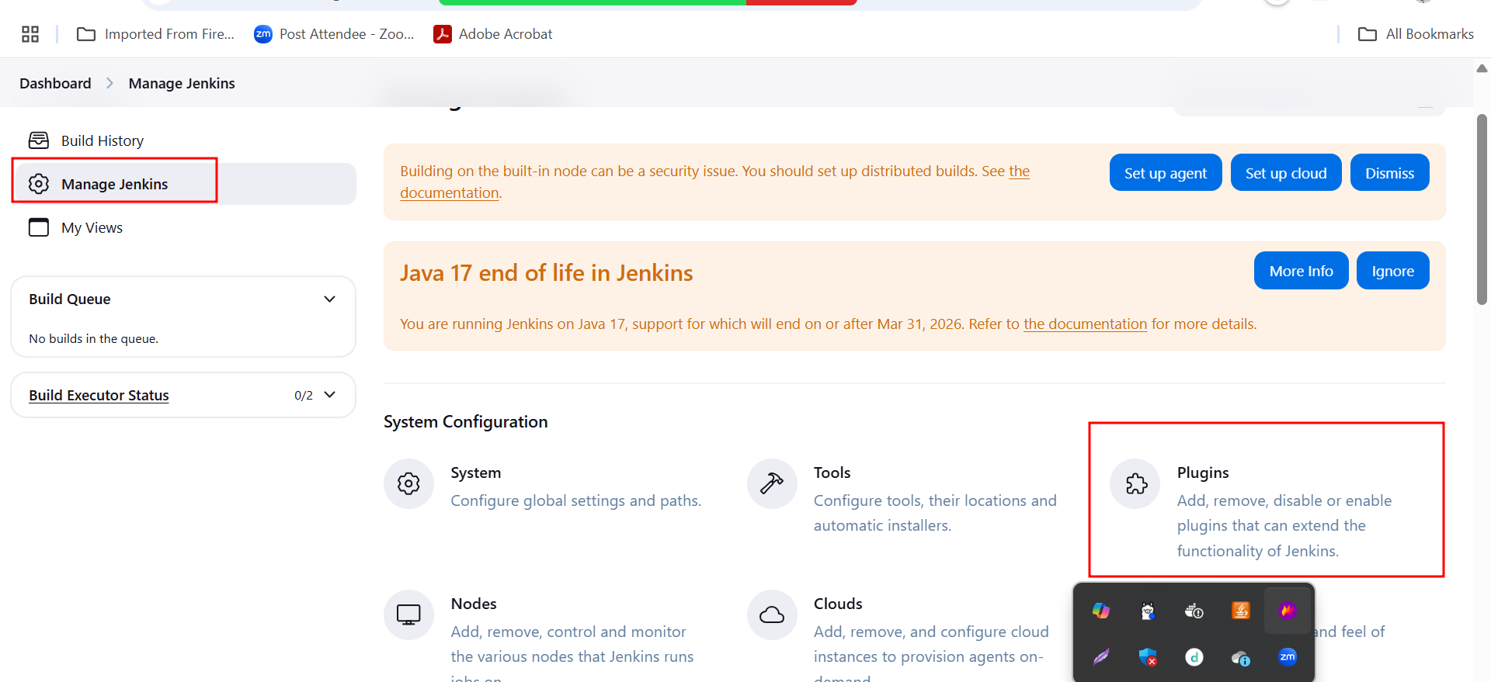

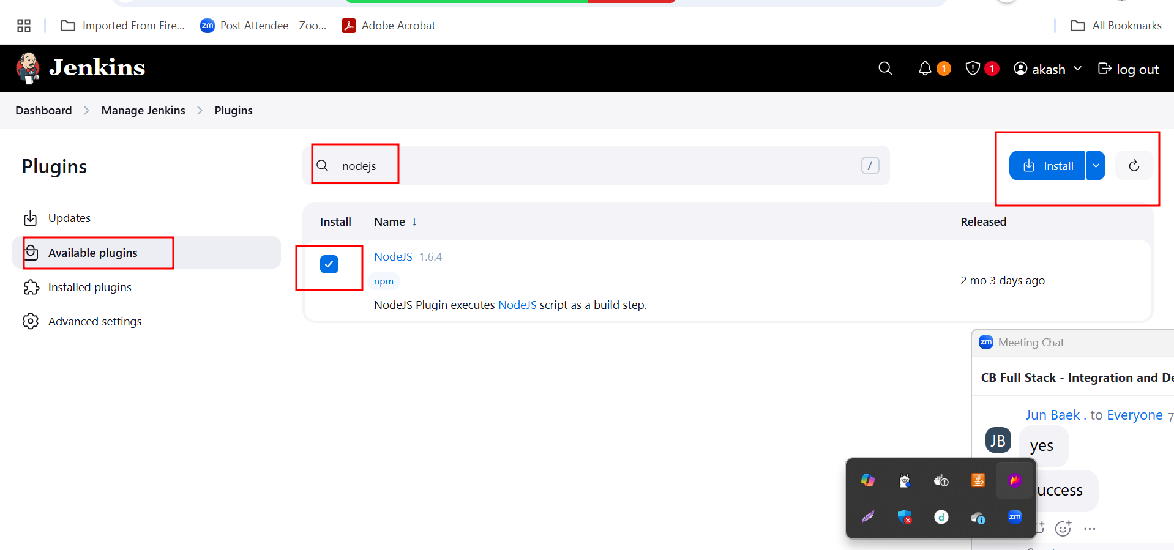

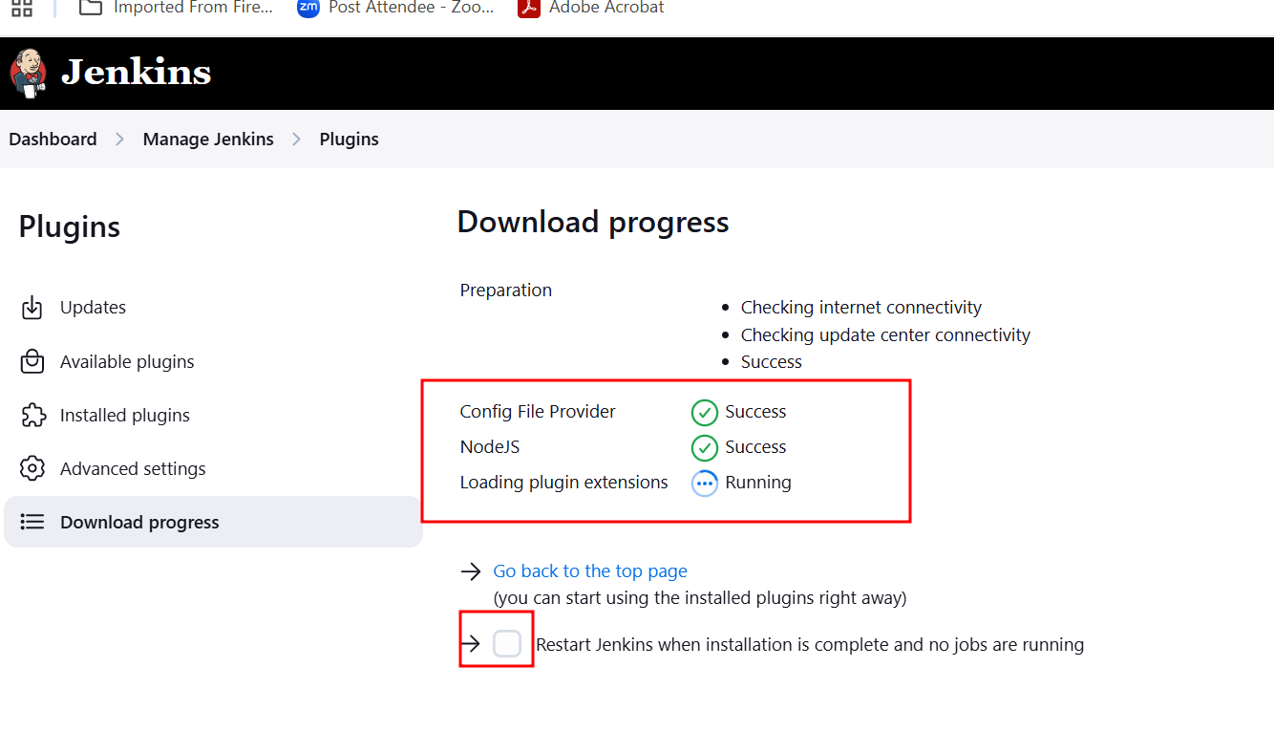

Angular project build in Jenkin

node -version

npm –version

npm install -g @angular/cli@16.0.1

ng new demo-app

ng serve it run the project with internal server on port number 4200

once development task done you need to build the project.

You need to stop

ng build

it will create build file and these build file we need to deploy on server with help of docker.

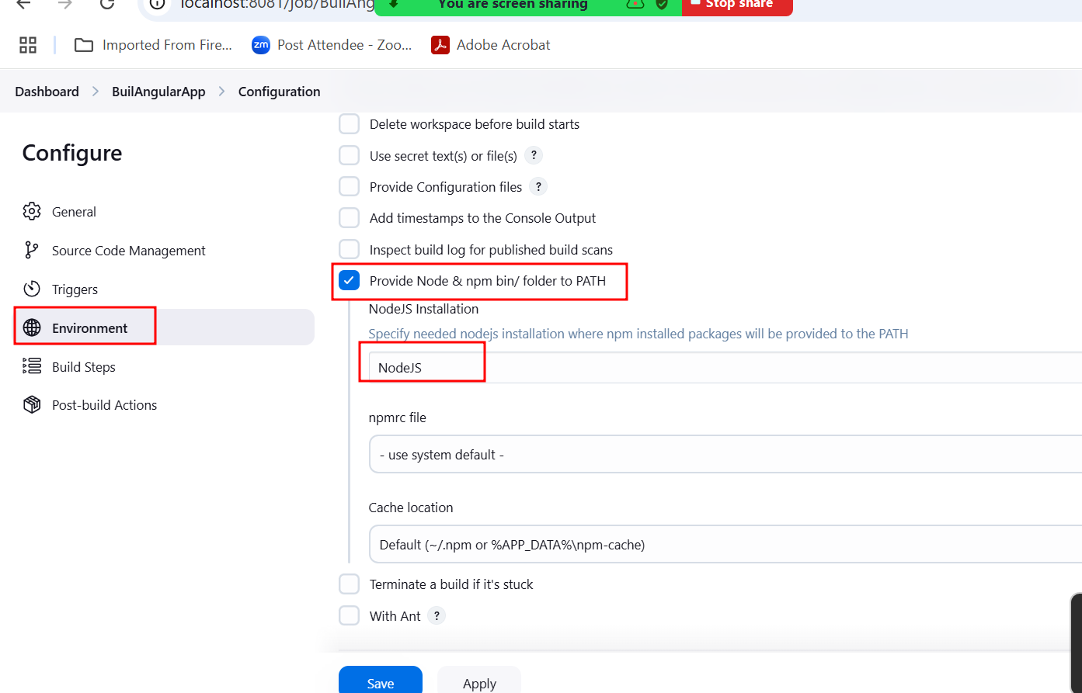

In build step

node --version check the node version

npm --version check the npm version

npm install install node_module folder

npm install -g @angular/cli@16.0.1 install ng command or enable ng command

ng build build angular project

installing other plugin like ocean it provide good look and feel for jobs

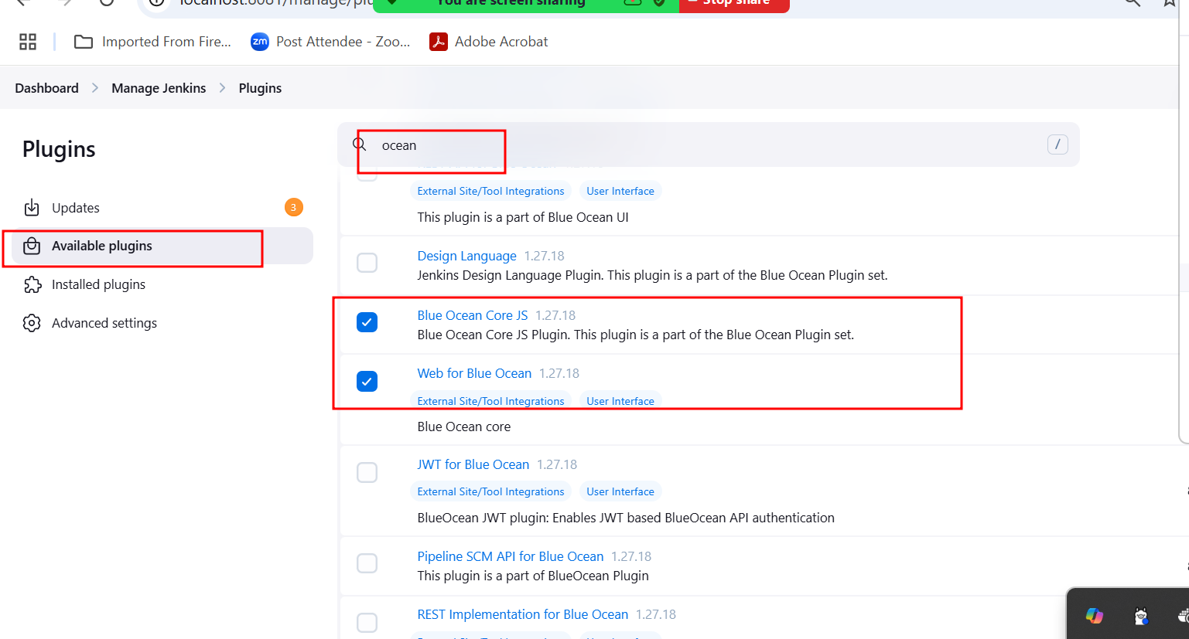

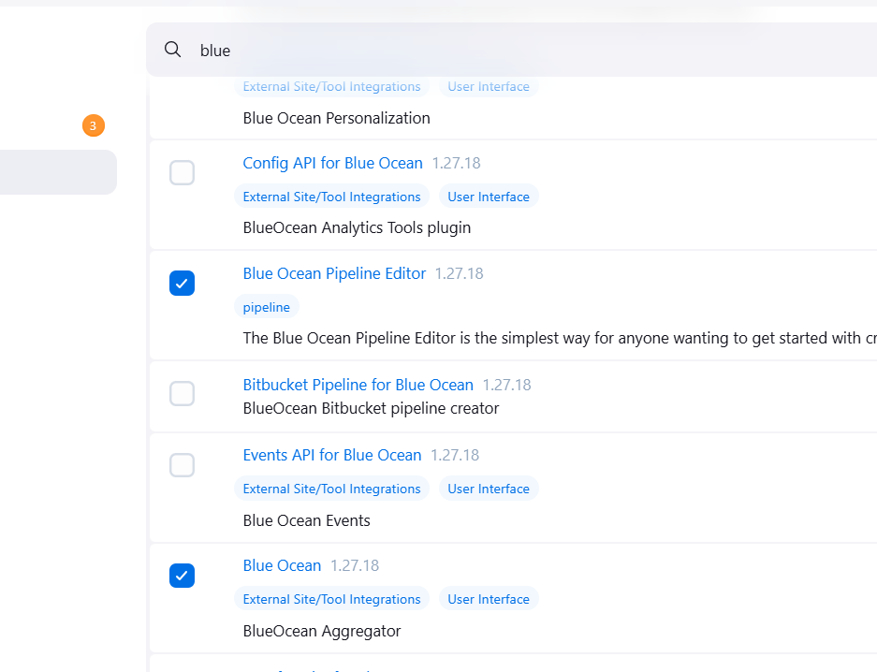

**AWS cloud computing**

If we run this job on AWS EC2 instance they provide us IP address

sss<http://198.34.56.188.8080>

--🡪

<http://www.akashkale.com>